SPECIAL BUDGET MEETING
WALWORTH COUNTY BOARD OF COMMISSIONERS
MINUTES OF PROCEEDINGS
Sep 23, 2025, 9:00 a.m.

Call to Order: Chairman Houck called the meeting to order at 9:00 a.m.

In Attendance: Commissioners Jim Houck, Duane Mohr, Justin Jungwirth, Randy Carlson via phone, Scott Schilling via phone, and Auditor Kim Dills. The public in attendance was Clare Schoelerman.

Pledge of Allegiance: The Pledge of Allegiance was recited by those in attendance.

Convene as County Commission
Agenda: Mohr moved to approve the agenda and seconded by Carlson. All in favor, all voting aye. Motion carried.

Budget: Mohr moved to approve the Annual Budget Adoption for 2026 and seconded by Carlson. Roll call, Carlson – yes, Jungwirth – abstain, Mohr – yes, Schilling – yes, Houck - yes. Motion carried.
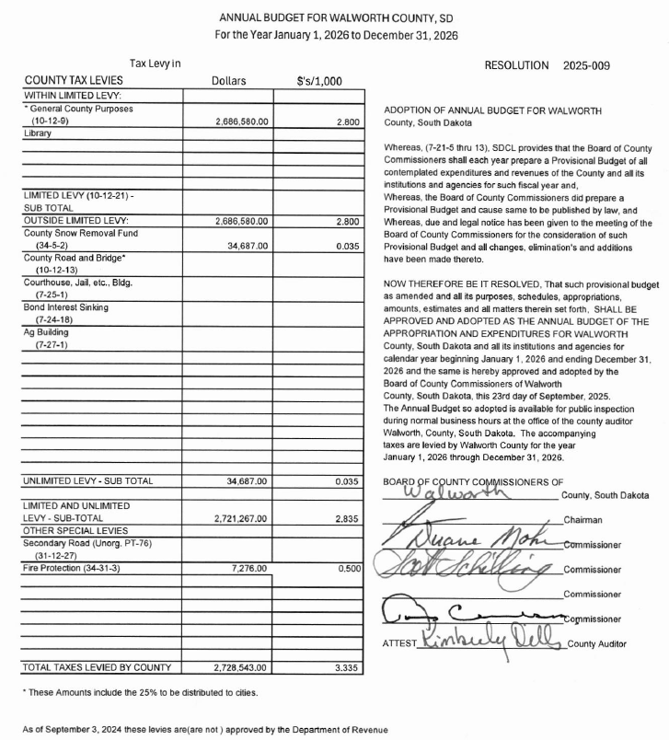
Old Business: None

New Business: None

Adjourn: Mohr moved to adjourn and seconded by Carlson. All in favor, all voting aye. Motion carried.

APPROVED: ATTEST:

_____________________________ __________________________
CHAIRPERSON AUDITOR

Published once at the total approximate cost of $____________

