$700,000.00
SELBY DEVELOPMENT, INC. – HIS GRACE HOLDINGS 2, LLC
5000 US HWY 12
SELBY LOT 1 SELBY MOTEL-CHS ADDN OT CITY OF SELBY
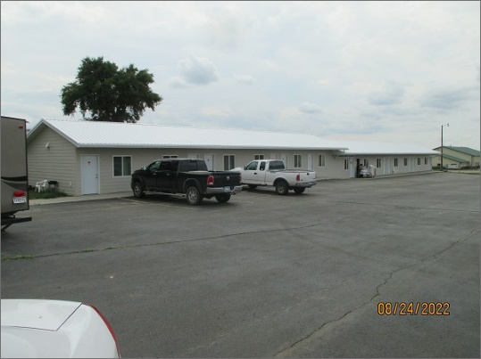
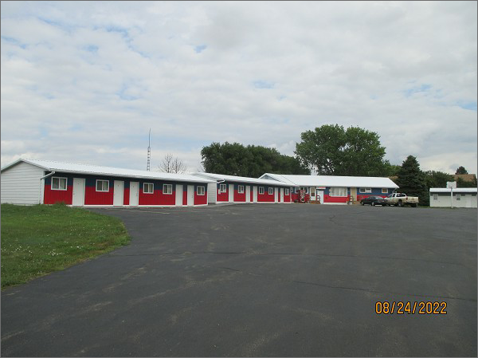
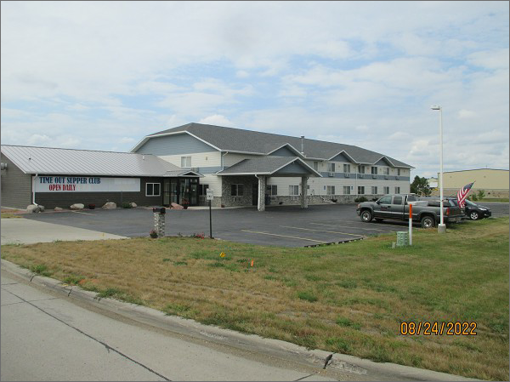
RECORD #7450 & 4634
LOT SIZE: 5.01 ACRES
YEAR BUILT: 1996
TYPE: COMMERCIAL – HOTEL/MOTEL
LAUNDROMAT
QUALITY: AVERAGE
CONDITION: AVERAGE
SOLD ON 4/28/22 FOR $700,000
SOLD ON 9/5/18 FOR $1,300,000
ASSESSED IN 2022 AT $706,855
ASSESSED IN 2017 AT $713,540

