$17,000.00
EVELYN M. TAUS LIVING TRUST U/A – SCHLOMER
023 MAIN POST OFFICE
GLENHAM, ORIGINAL, LOT 1, BLOCK 4
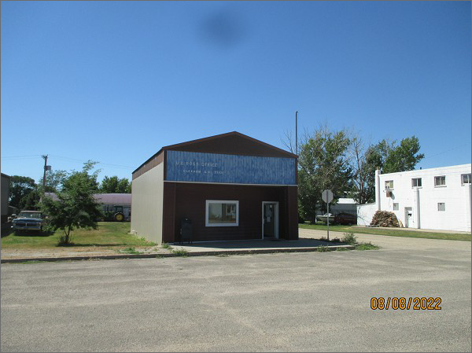
RECORD #6609
LOT SIZE: 25’ X 140’
YEAR BUILT: 1900
TYPE: COMMERCIAL – POST OFFICE
QUALITY: AVERAGE
CONDITION: AVERAGE
TOTAL FLOOR AREA: 1128 SQFT
SOLD ON 10/12/21 FOR $17,000
ASSESSED IN 2021 AT $19,750
ASSESSED IN 2017 AT $17,910

