$135,000.00
DOUGLAS – GREGER
1508 10TH AVENUE WEST
MOBRIDGE, SUBD OF NW4 19-124-79. S 25’ OF W 186.2’ OF TRACT 1 & N 125’ OF W 186.2’ OF TRACT 2.
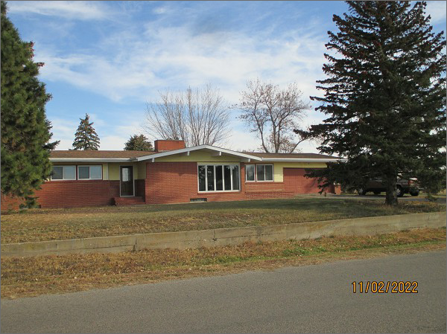
RECORD #6544
LOT SIZE: 150’ X 186.2’
YEAR BUILT: 1960
TYPE: SINGLE FAMILY
QUALITY: AVERAGE
CONDITION: AVERAGE
GROUND FLOOR AREA: 2590 SQFT
BASEMENT: 2590 SQFT
BEDROOMS: 3. BATHS: 2
GARAGE – ATTACHED: 760 SQFT
SOLD ON 9/22/2022 FOR $135,000
ASSESSED IN 2022 AT $178,960
ASSESSED IN 2017 AT $171,480

