$195,000.00
LLOYD – SUMEY
108 13TH STREET EAST
MOBRIDGE – THOMPSON’S OUTLOTS, LOTS 16A1, 16A2, 16B1 & 16B2
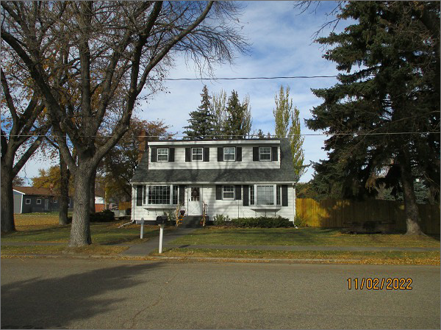
RECORD #6492
LOT SIZE: 72.5’ X 132’
YEAR BUILT: 1950
TYPE: SINGLE FAMILY
QUALITY: AVERAGE
CONDITION: AVERAGE
GROUND FLOOR AREA: 936 SQFT
BASEMENT: 936 SQFT
BEDROOMS: 4. BATHS: 2
FIXTURES: 8
SOLD ON 5/19/2022 FOR $195,000
SOLD ON 6/7/2019 FOR $160,000
ASSESSED IN 2022 AT $110,920
ASSESSED IN 2017 AT $90,000

