$350,000.00
MERGEN – CORDELL
1309 KENNEDY DRIVE
MOBRIDGE, SHOR ACRES, LOT 113 & S 6’ OF RTWY BTWN LOTS 112 & 113
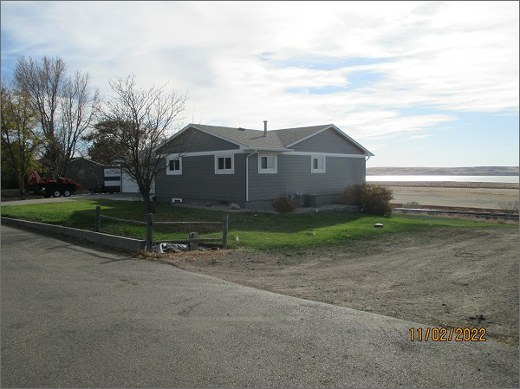
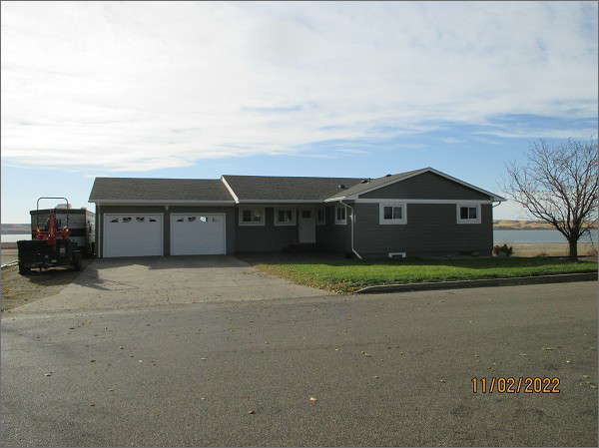
RECORD #6224
LOT SIZE: 146’ x 135,98’
YEAR BUILT: 1967
TYPE: SINGLE FAMILY
QUALITY: AVERAGE
CONDITION: AVERAGE
GROUND FLOOR AREA: 1414 SQFT
BASEMENT: 850 SQFT
BEDROOMS: 3. BATHS: 1 ¾
FIXTURES: 11
GARAGE – ATTACHED: 598 SQFT
SOLD ON 10/31/22 FOR $350,000
SOLD ON 10/6/15 FOR $186,000
ASSESSED IN 2022 AT $189,530
ASSESSED IN 2017 AT $182,850
ASSESSED IN 2015 AT $200,480

