$175,000.00
EISEMANN – FRYHLING
1505 WEST GRAND CROSSING
MOBRIDGE, SHOR ACRES, S 264.86’ OF LOT B EXC N 31’.
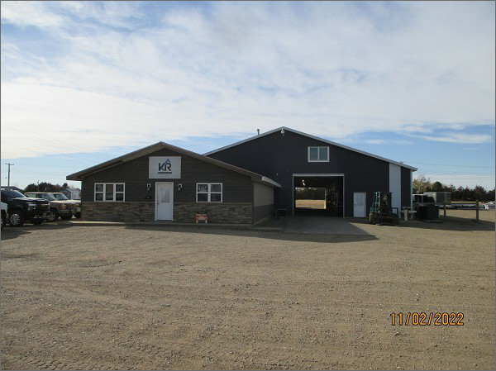
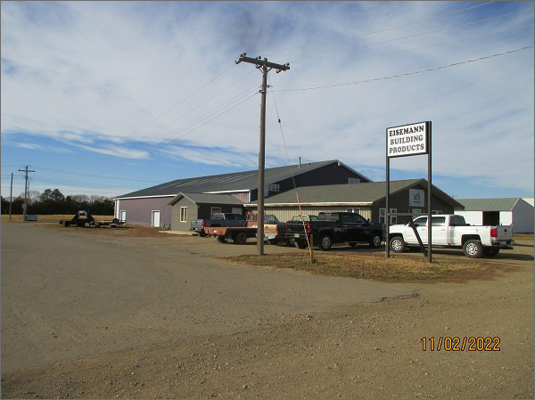
RECORD #6388
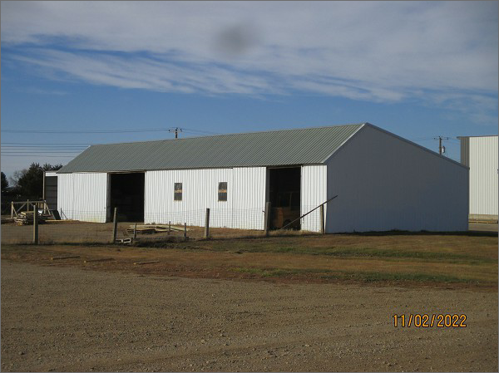
LOT SIZE: 1.76 ACRES
YEAR BUILT: 1985
TYPE: COMMERCIAL
QUALITY: AVERAGE
CONDITION: AVERAGE
TOTAL FLOOR AREA: 9840 SQFT
SOLD ON 9/7/2022 FOR $175,000
SOLD ON 4/22/2013 FOR $120,000
ASSESSED IN 2022 AT $170,120
ASSESSED IN 2017 AT $169,480
ASSESSED IN 2013 AT $118,690

