$275,000.00
PLATINUM PC, LLC – PAHLKE
1711 WEST HIGHWAY 12
MOBRIDGE, SHOR ACRES, S 100’ OF N 350’ OF LOT B
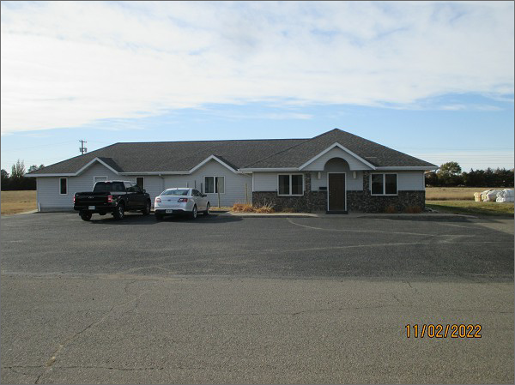
RECORD #6386
LOT SIZE: 100’ X 230’
YEAR BUILT: 1993
TYPE: COMMERCIAL – OFFICE/CLINIC
QUALITY: AVERAGE
CONDITION: AVERAGE
TOTAL FLOOR AREA: 2892 SQFT
SOLD ON 8/23/2022 FOR $275,000
SOLD ON 2/23/2017 FOR $260,000
ASSESSED IN 2022 AT $220,000
ASSESSED IN 2017 AT $220,000

