$125,000.00
QUENZER – SIVERTSON & FISCHER
317 MAIN STREET
MOBRIDGE ORIGINAL LOT 4, BLOCK 3
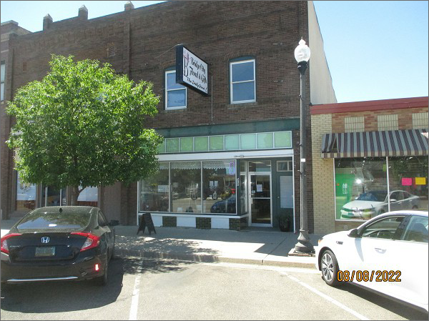
RECORD #6244
LOT SIZE: 25’ X 140’
YEAR BUILT: 1920’S
TYPE: COMMERCIAL – %50 RETAIL/%50 RESIDENTIAL
QUALITY: AVERAGE
CONDITION: AVERAGE
TOTAL FLOOR AREA: 4000 SQFT
BASEMENT: 2000 SQFT UNFINISHED/STORAGE
SOLD ON 1/13/22 FOR $125,000
ASSESSED IN 2022 AT $46,960
ASSESSED IN 2017 AT $46,960

