$500,000.00
DEACON – HEIER PROPERTIES, LLC
DAIRY QUEEN
MOBRIDGE, MILW LAND CO’S 2ND ADDN. LOTS 11 & 12, BLOCK 27
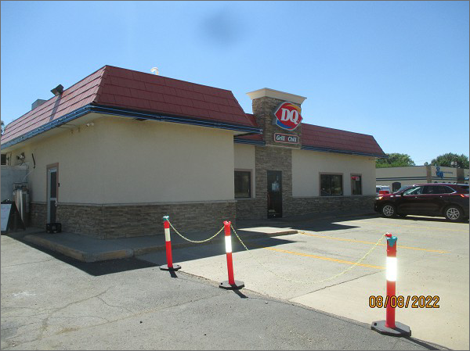
RECORD #5865
LOT SIZE: 50’ X 140’
YEAR BUILT: 1950
TYPE: COMMERCIAL – FAST FOOD
QUALITY: AVERAGE
CONDITION: AVERAGE
TOTAL FLOOR AREA: 1624 SQFT
SOLD ON 3/4/22 FOR $500,000
ASSESSED IN 2022 AT $122,415
ASSESSED IN 2017 AT $125,895

