$100,000.00
DEACON – HEIER PROPERTIES, LLC
411 EAST GRAND CROSSING
MOBRIDGE, MILW LAND CO’S 2ND ADDN. LOTS 1 & 2, BLOCK 27
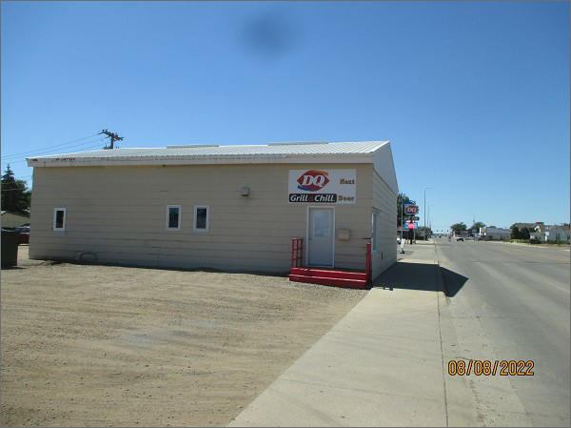
RECORD #5856
LOT SIZE: 140’ X 100’
TYPE: COMMERCIAL – RETAIL/WAREHOUSE
QUALITY: AVERAGE
CONDITION: AVERAGE
TOTAL FLOOR AREA: 1920 SQFT
SOLD ON 3/4/22 FOR $100,000
ASSESSED IN 2022 AT $54,175
ASSESSED IN 2017 AT $54,175

