$100,000.00
BAUER – SCHAFFER
INTERSECTION OF 1ST AVENUE WEST & 4TH STREET WEST
MOBRIDGE, MILW LAND CO’S 1ST ADDN, W2 LOTS 13 M& 14, & S 25’ OF W2 OF LOT 15, BLOCK 22
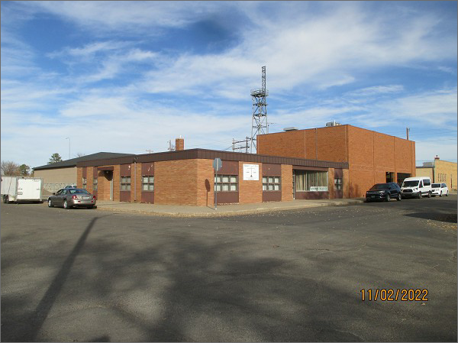
RECORD #5812
LOT SIZE: 70’ X 100’ & 25’ X 70’
YEAR BUILT: 1960
TYPE: COMMERCIAL – OFFICE
QUALITY: AVERAGE
CONDITION: AVERAGE
TOTAL FLOOR AREA: 4200 SQFT
SOLD ON 4/4/22 FOR $100,000
ASSESSED IN 2022 AT $68,555
ASSESSED IN 2017 AT $68,555

