$50,000.00
PEACOCK – JUENEMAN PROPERTIES, LLC
TACO JOHN’S
MOBRIDGE, MILW LAND CO’S 1ST ADDN. LOTS 1 & 2, BLOCK 20
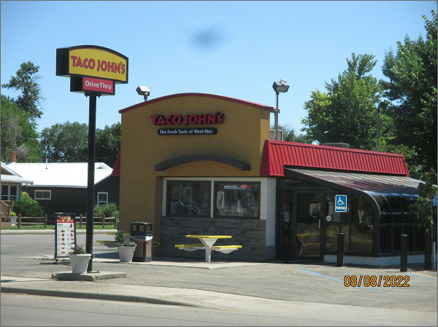
RECORD #5789
LOT SIZE: 140’ X 100’
TYPE: COMMERCIAL – FAST FOOD
QUALITY: AVERAGE
CONDITION: AVERAGE
TOTAL FLOOR AREA: 698 SQFT
SOLD ON 3/24/22 FOR $50,000
ASSESSED IN 2022 AT $51,286
ASSESSED IN 2017 AT $47,729

