$37,000.00
RICH – POUST
717 3RD STREET EAST
MOBRIDGE LARSON’S REARRANGEMENT, LOTS 1-3
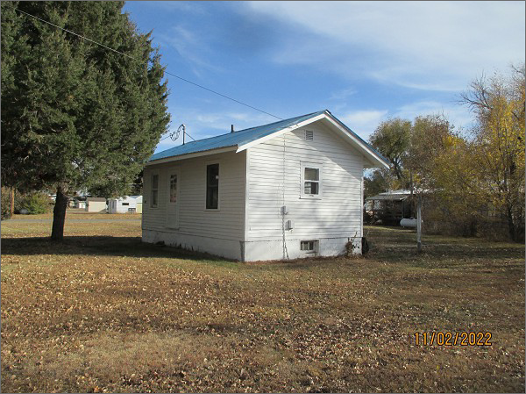
RECORD #5557
LOT SIZE: 105’ X 106.8’
YEAR BUILT: 1917
TYPE: SINGLE FAMILY
QUALITY: LOW
CONDITION: BADLY WORN
GROUND FLOOR AREA: 384 SQFT
BASEMENT: 384 SQFT
BEDROOMS: 1. BATHS: 1
FIXTURES: 5
SOLD ON 7/29/22 FOR $37,000
ASSESSED IN 2022 AT $14,320
ASSESSED IN 2017 AT $14,320

