$12,200.00
STOLLER – WHILE
710 3RD AVENUE EAST
MOBRIDGE – GRAND CROSSING ADDN., LOT 2E, BLOCK 61
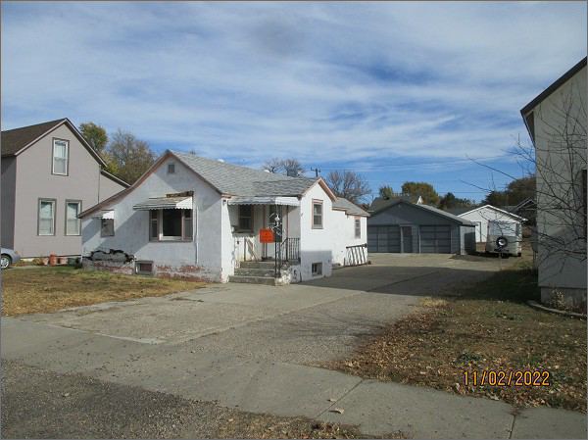
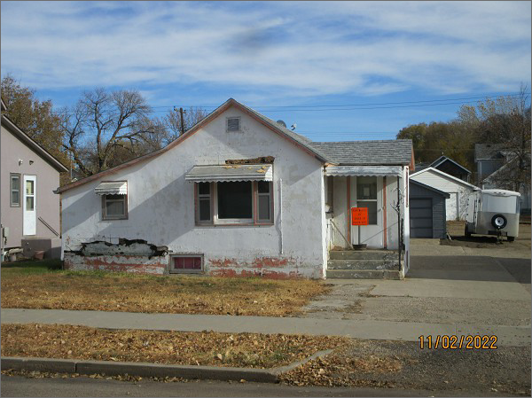
RECORD #5476
LOT SIZE: 43’ X 140’
YEAR BUILT: 1920
TYPE: SINGLE FAMILY
QUALITY: FAIR
CONDITION: BADLY WORN
GROUND FLOOR AREA: 842 SQFT
BASEMENT: 336 SQFT
BEDROOMS: 2. BATHS: 1.5
FIXTURES: 5
SOLD ON 10/13/2022 FOR $12,200
ASSESSED IN 2022 AT $18,840
ASSESSED IN 2017 AT $17,850

