$358,000.00
QUENZER – PEACOCK
LOCATION ADDRESS
GRAND CROSSING ADDN. N 45’ OF LOT 17 ALL OF LOT 18 BLOCK 43.
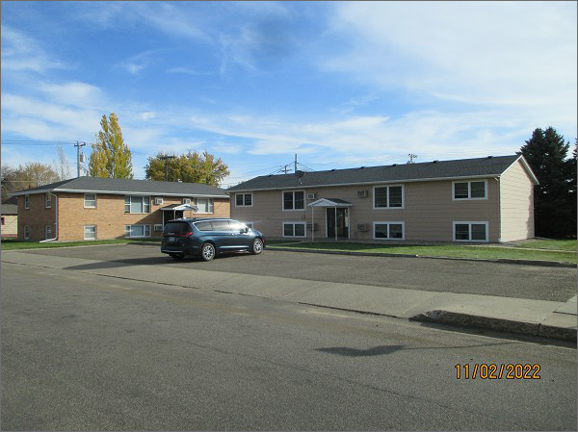
RECORD #5341
LOT SIZE: 95’ X 140’
TYPE: COMMERCIAL – MULTI-RESIDENTIAL
QUALITY: AVERAGE
CONDITION: AVERAGE
GROUND FLOOR AREA: 3456 SQFT
BASEMENT: 3456 SQFT
SOLD ON 4/26/22 FOR $358,000
ASSESSED IN 2022 AT $145,835
ASSESSED IN 2017 AT $147,245

