$69,900.00
HEIL – NEIDHART PROPERTIES, LLC
518 4TH AVENUE WEST
MOBRIDGE, GRAND CROSSING ADDN, LOT 11, BLOCK 38
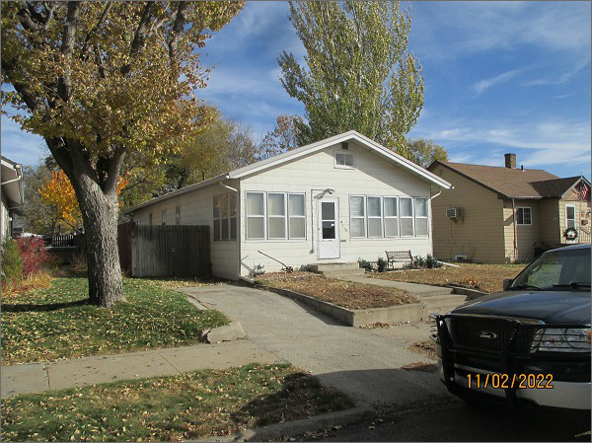
RECORD #5306
LOT SIZE: 50’ X 140’
YEAR BUILT: 1940
TYPE: SINGLE FAMILY
QUALITY: FAIR
CONDITION: AVERAGE
GROUND FLOOR AREA: 1157 SQFT
BASEMENT: 1157 SQFT
BEDROOMS: 3. BATHS: 1 ¾
FIXTURES: 7
GARAGE – DETACHED: 216 SQFT
SOLD ON 10/27/22 FOR $69,900
ASSESSED IN 2022 AT $44,170
ASSESSED IN 2017 AT $43,010

