$30,000.00
OVERSETH – FUHRER
222 10TH AVENUE EAST
MOBRIDGE, DRAEGERS 1ST ADDN. LOTS 11 & 12, BLOCK 11
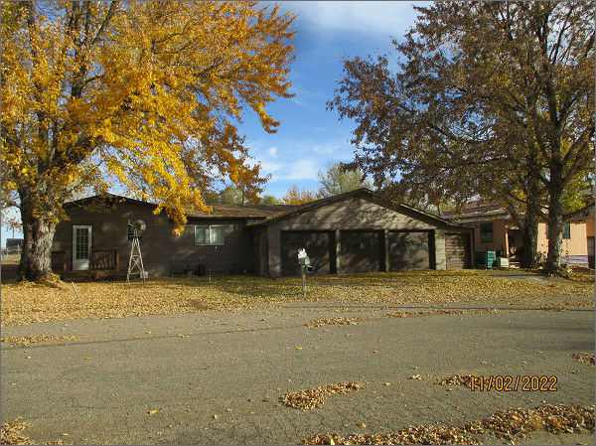
RECORD #4845
LOT SIZE: 100’ X 140’
YEAR BUILT: 1945
TYPE: SINGLE FAMILY
QUALITY: FAIR
CONDITION: AVERAGE
GROUND FLOOR AREA: 1231 SQFT
BEDROOMS: 2. BATHS: 1 ½
FIXTURES: 7
GARAGE – ATTACHED: 1152 SQFT
SOLD ON 9/14/22 FOR $30,000
ASSESSED IN 2022 AT $36,190
ASSESSED IN 2017 AT $36,190

