$109,000.00
GETZ & WALKER – VOJTA & KECK
514 CRESCENT DRIVE
MOBRIDGE, BEL AIRE 1ST ADDN., LOT 2, BLOCK 5
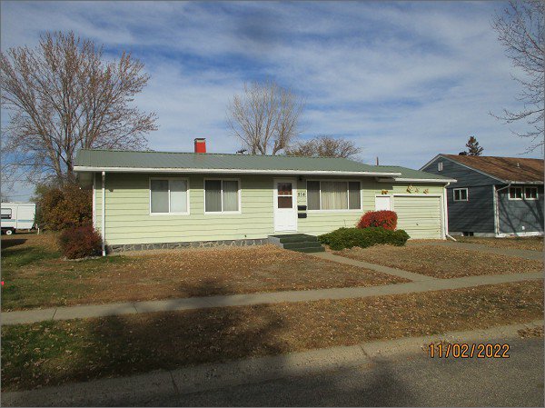
RECORD #4718
LOT SIZE: 60’ X 130’
YEAR BUILT: 1958
TYPE: SINGLE FAMILY
QUALITY: FAIR
CONDITION: AVERAGE
GROUND FLOOR AREA: 925 SQFT
BASEMENT: 925 SQFT
BEDROOMS: 2. BATHS: 2
FIXTURES: 8
GARAGE – ATTACHED: 375 SQFT
SOLD ON 10/12/2022 FOR $109,000.00
ASSESSED IN 2022 AT $83,070
ASSESSED IN 2017 AT $80,350

