$20,000.00
AGTEGRA COOPERATIVE – KIHNE
MAIN STREET
SELBY ORIGINAL, LOT 4, BLOCK 4
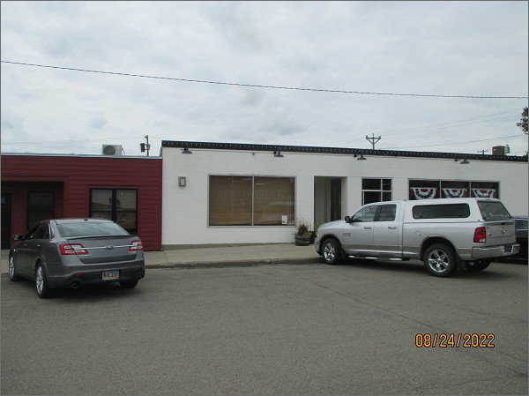
RECORD #4424
LOT SIZE: 25’ X 140’
YEAR BUILT: 1951
TYPE: COMMERCTIAL – RETAIL
QUALITY: AVERAGE
CONDITION: AVERAGE
TOTAL FLOOR AREA: 1508 SQFT
SOLD ON 4/26/22 FOR $20,000
ASSESSED IN 2022 AT $19,310
ASSESSED IN 2017 AT $18,340

