$225,000.00
VOEGELE – SPORTSMAN BAR & GRILL, LLC
INTERSECTION OF HOLMES AVENUE & MAIN STREET.
AKASKA, ORIGINAL, LOTS 10-13, BLOCK 15
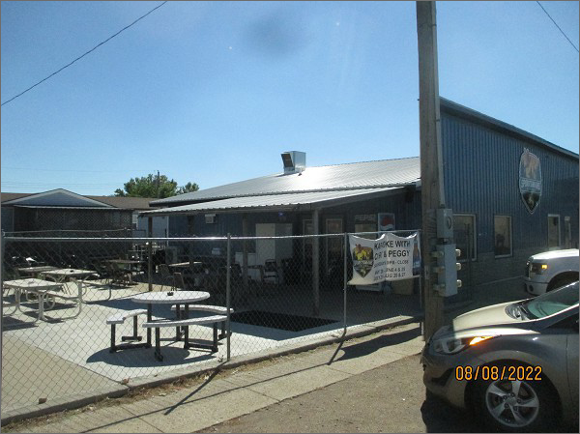
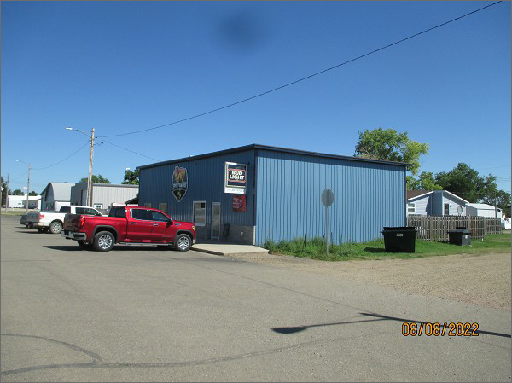
RECORD #3887
LOT SIZE: 96’ X 125’
YEAR BUILT: 1939
TYPE: COMMERCIAL – LOUNGE/RESTURANT
QUALITY: AVERAGE
CONDITION: AVERAGE
TOTAL FLOOR AREA: 2080 SQFT
SOLD ON 3/3/22 FOR $225,000
ASSESSED IN 2022 AT $101,995
ASSESSED IN 2017 AT $90,025

