$15,000.00
SACKREITER DEVELOPMENT, LLC – KENNY JENSEN RENTALS, LLC
INTERSECTION OF 17TH AVENUE EAST & 2ND STREET EAST
TRACT S-3 REPLAT PART OUTLOT D & N 42.8’ OF OUTLOT E, E MOB ADDN IN NE4 29-124-79
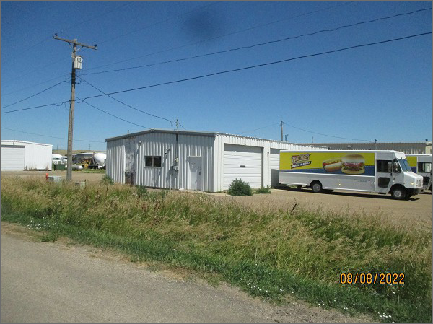
RECORD #3765
LOT SIZE: 120’ X 140’
YEAR BUILT: 1970
TYPE: COMMERCIAL – SERVICE GARAGE/WAREHOUSE
QUALITY: AVERAGE
CONDITION: AVERAGE
TOTAL FLOOR AREA: 2160 SQFT
SOLD ON 11/24/21 FOR $15,000
ASSESSED IN 2022 AT $38,235
ASSESSED IN 2017 AT $37,100

