$395,000.00
OLSON – GARDINO
29261 ORCHARD ROAD
TRACT 3 IN TURNER ADDN IN N2NW4SE4 6-123-78
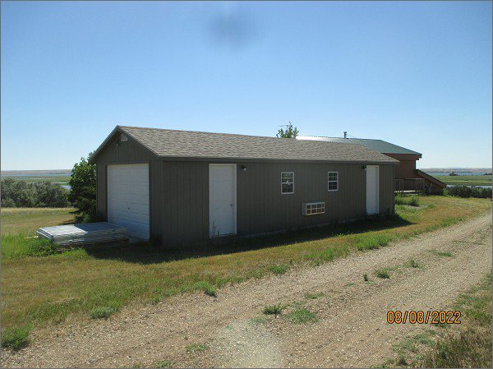
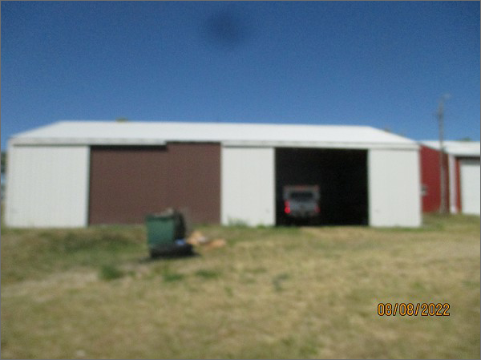
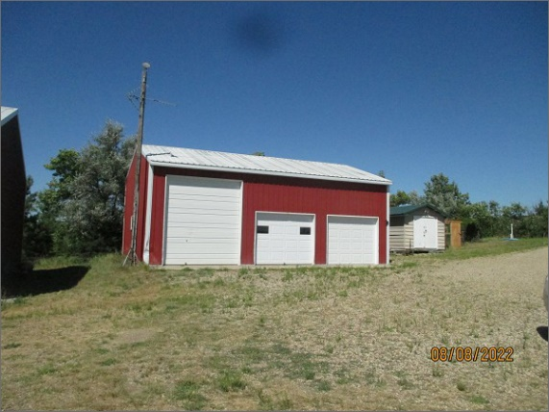
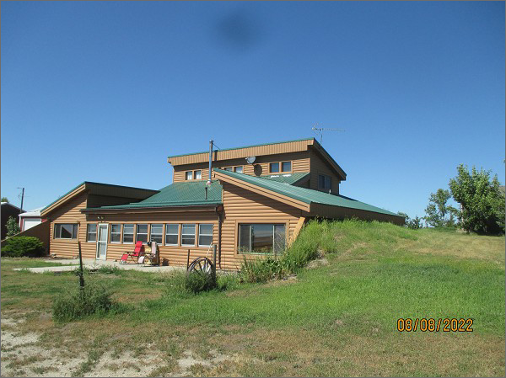
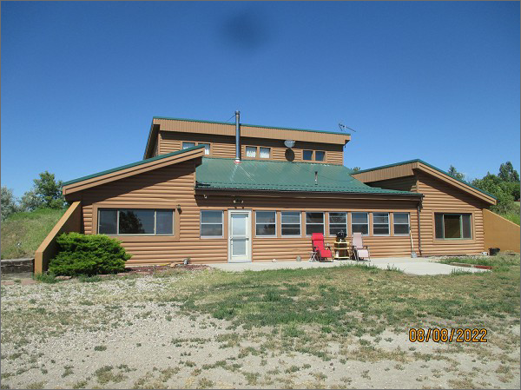
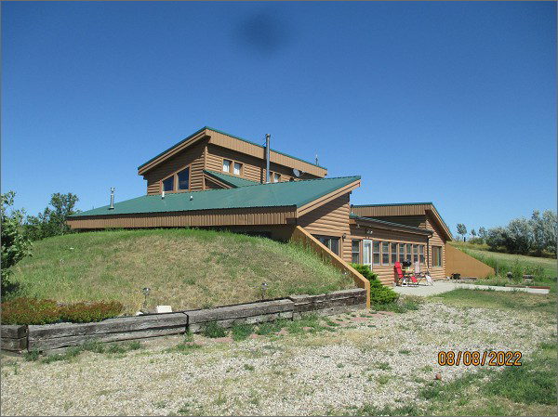
RECORD #2280

LOT SIZE: 8.98 ACRES
YEAR BUILT: 1995
TYPE: SINGLE FAMILY
QUALITY: AVERAGE
CONDITION: AVERAGE
GROUND FLOOR AREA: 1920 SQFT
BEDROOMS: 3. BATHS: 1
FIXTURES: 5
SOLD ON 8/2/2021 FOR $395,000
ASSESSED IN 2021 AT $196,585
ASSESSED IN 2017 AT $196,585

