$180,000.00
RYPKEMA & TARRANT – DELL
313 WEST COFFEY STREET
AKASKA – ORIGINAL, BLOCK 6, LOT 4 & N70’ OF LOT 5
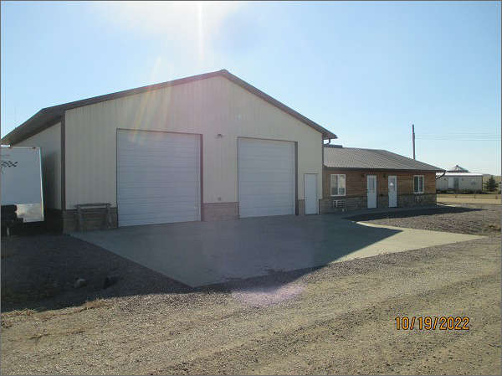
RECORD #8607
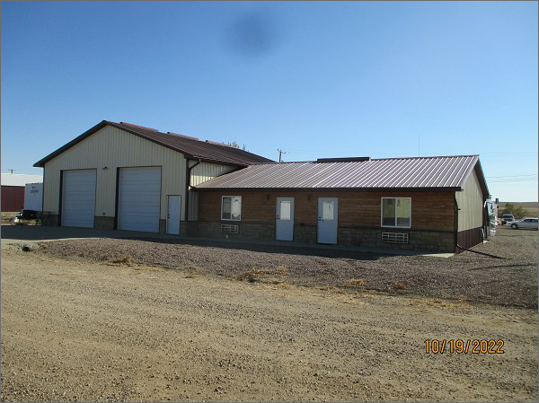

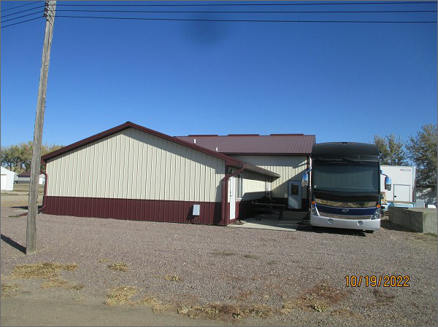
LOT SIZE: 57.6’ X 132’ & 57.6’ X 70’
YEAR BUILT: 2014
TYPE: SINGLE FAMILY
QUALITY: AVERAGE
CONDITION: AVERAGE
GROUND FLOOR AREA: 1260 SQFT
BEDROOMS: 2. BATHS: 2
GARAGE – ATTACHED: 1932 SQFT
SOLD ON 1/6/2022 FOR $180,000
ASSESSED IN 2022 AT $151,440
ASSESSED IN 2019 AT $148,720
ASSESSED IN 2016 AT $212,290

