$95,000.00
GRAGE – HUTCHINS
ACROSS FROM EACH OTHER ON COFFEY STREET
AKASKA – ORIG, W12.5’ OF S95’ OF LT 4 & E37.5’ OF S95’ OF LT 5 BLK 1
AKASKA – ORIG, LOT 4, BLOCK 11
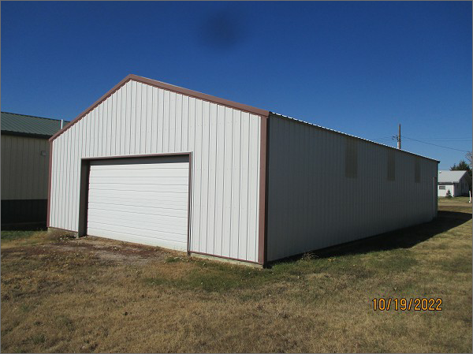
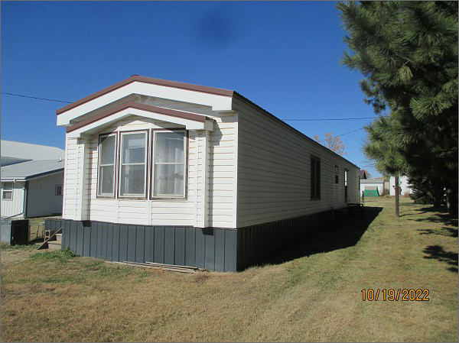
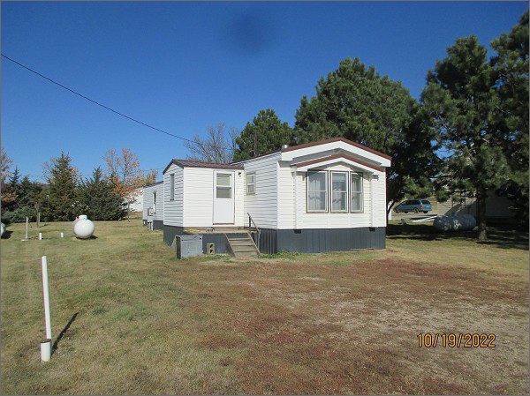
RECORD #7660 & 8163
LOT SIZE 50’ X 95’ & 57.6’ X 132’
YEAR BUILT: 1990
TYPE: MANUFACTURED HOUSING
QUALITY: AVERAGE
CONDITION: AVERAGE
GROUND FLOOR AREA: 1216 SQFT
BEDROOMS: 3. BATHS: 1.75
FIXTURES: 5
SHED: 1440 SQFT
SOLD ON 9/30/2021 FOR $95,000
ASSESSED IN 2022 AT $75,310
ASSESSED IN 2021 AT $73,110
ASSESSED IN 2017 AT $66,220

