$105,000
GREMMELS – PFEIFER, INC.
320 8TH ST EAST
MOBRIDGE – MAIN PARK, BLOCK 5, S. ½ OF LOT 7 & ALL OF LOT 8
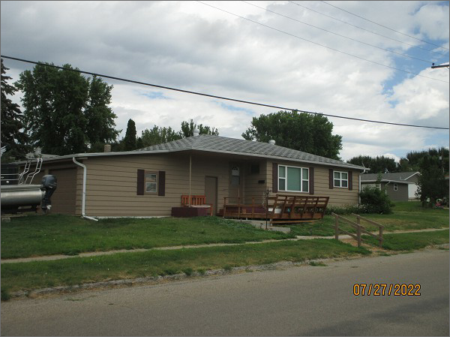
RECORD #7228
LOT SIZE: 56.25’ X 142’
YEAR BUILT: 1960
TYPE: SINGLE FAMILY
QUALITY: AVERAGE
CONDITION: AVERAGE
GROUND FLOOR AREA: 1176 SQFT
BASEMENT: 840 SQFT
BEDROOMS: 2. BATHS: 1.75
FIXTURES: 8
GARAGE – ATTACHED: 336 SQFT
SOLD ON 6/2/22 FOR $105,000
SOLD ON 10/16/20 FOR $77,500
ASSESSED IN 2022 AT $116,250
ASSESSED IN 2017 AT $113,650

