$21,000
PETERSON & ASMUSSEN – BRIDGE CITY PROPERTIES LLC
611 EAST GRAND CROSSING UNIT 12
MOBRIDGE – RINEHART’S ADDN., FISHERMAN’S CONDO UNIT #12
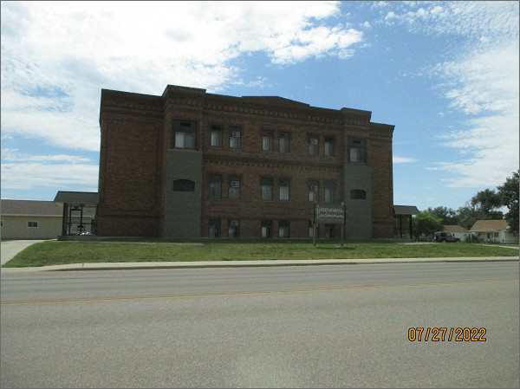
RECORD #6376
LOT SIZE: 1 UNIT
YEAR BUILT: 1930
TYPE: CONDOMINIUM
QUALITY: AVERAGE
CONDITION: AVERAGE
GROUND FLOOR AREA: 536 SQFT
BEDROOMS: 2. BATHS: 1.5
FIXTURES: 5
SOLD ON 6/28/22 FOR $21,000
SOLD ON 7/19/16 FOR $17,300
ASSESSED IN 2022 AT $16,520
ASSESSED IN 2017 AT $16,000
ASSESSED IN 2012 AT $16,000

