$18,000
PETERSON, SCHOLL, ASMUSSEN – BRIDGE CITY PROPERTIES, LLC
611 EAST GRAND CROSSING UNIT 8
MOBRIDGE – RINEHART’S ADDN., FISHERMAN’S CONDO UNIT #8
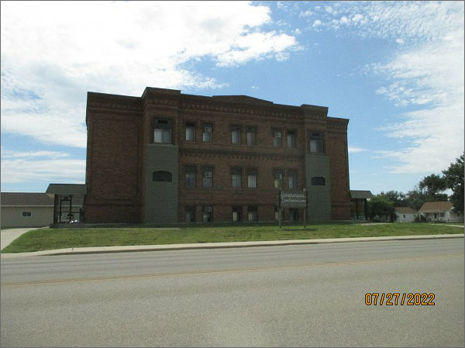
RECORD #6372
LOT SIZE: 1 UNIT
YEAR BUILT: 1930
TYPE: CONDOMINIUM
QUALITY: AVERAGE
CONDITION: AVERAGE
GROUND FLOOR AREA: 538 SQFT
BEDROOMS: 2. BATHS: 1.5
FIXTURES: 5
SOLD ON 6/28/22 FOR $18,000
SOLD ON 10/10/12 FOR $15,000
ASSESSED IN 2022 AT $13,790
ASSESSED IN 2017 AT $13,270
ASSESSED IN 2012 AT $13,270

