$135,000
VAN VUGT – HOLLENBECK
819 7TH STREET WEST
MOBRIDGE – NWTS CO’S 3RD ADDN., LOT 12, BLOCK 39
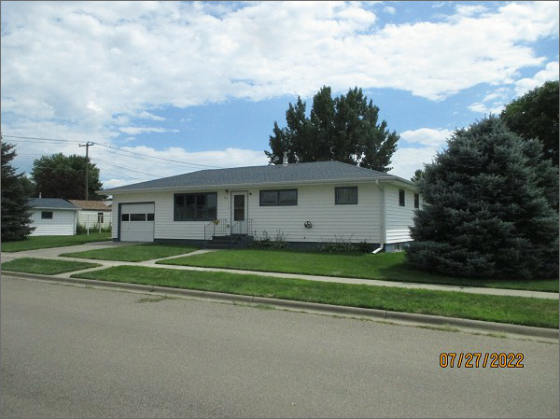
RECORD #6204
LOT SIZE: 50’ X 140’
YEAR BUILT: 1960
TYPE: SINGLE FAMILY
QUALITY: FAIR
CONDITION: AVERAGE
GROUND FLOOR AREA: 960 SQFT
BASEMENT: 960 SQFT
BEDROOMS: 5. BATHS: 2
FIXTURES: 8
GARAGE – DETACHED: 384 SQFT. ATTACHED: 288 SQFT
SOLD ON 7/20/22 FOR $135,000
ASSESSED IN 2022 AT $85,130
ASSESSED IN 2017 AT $83,970

