**$110,000.00**

**SCHAFER – HOVORKA**

**914 8TH STREET WEST**

**MOBRIDGE NWTS CO’S 3RD ADDN., BLOCK 32, E2 OF LOTS 7 & 8**

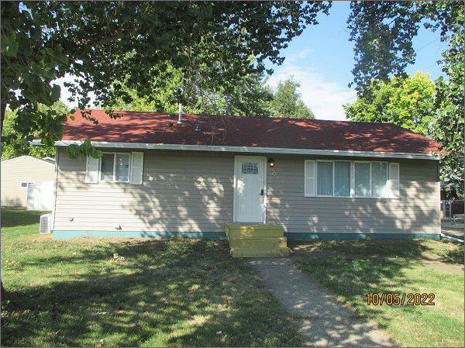**RECORD #6155**

**LOT SIZE: 60’ X 100’**

**YEAR BUILT: 1955**

**TYPE: SINGLE FAMILY**

**QUALITY: AVERAGE**

**CONDITION: GOOD**

**GROUND FLOOR AREA: 960 SQFT**

**BASEMENT: 960 SQFT**

**BEDROOMS: 3. BATHS: 1. FIXTURES: 5**

**SOLD ON 5/20/2022 FOR $110,000**

**SOLD ON 10/22/2020 FOR $94,000**

**SOLD ON 11/21/2017 FOR $72,000**

**SOLD ON 10/2/2015 FOR $23,000**

**ASSESSED IN 2022 AT $85,870**

**ASSESSED IN 2018 AT $67,600**

**ASSESSED IN 2015 AT $43,350**