$65,000.00
KLUCAS – WILLIAMS
1014 8TH STREET WEST
MOBRIDGE – NWTS CO’S 3RD ADDN., BLOCK 31, LOTS 5 & 6
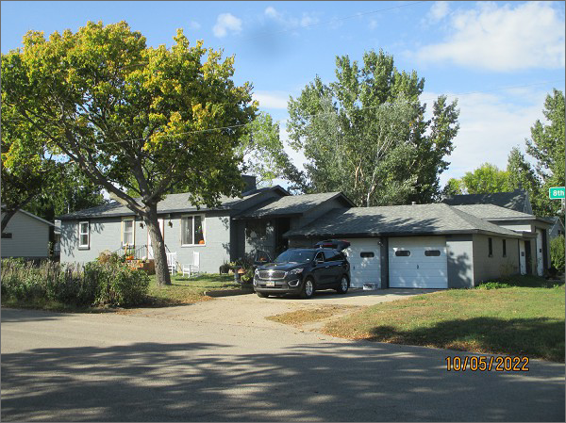
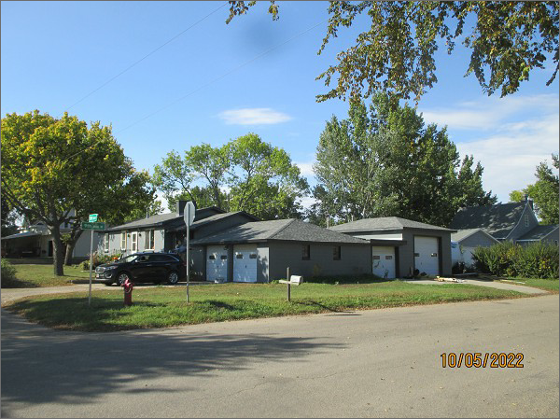
RECORD #6144
LOT SIZE: 100’ X 120’
YEAR BUILT: 1960
TYPE: SINGLE FAMILY
QUALITY: FAIR
CONDITION: AVERAGE
GROUND FLOOR AREA: 1180 SQFT
BASEMENT: 960 SQFT
BEDROOMS: 4. BATHS: 1.5
FIXTURES: 5
GARAGE – ATTACHED: 1416 SQFT
SOLD ON 4/1/2022 FOR $65,000
ASSESSED IN 2022 AT $58,990
ASSESSED IN 2017 AT $52,760

