$135,000
GRETHE – RICE
901 9TH AVENUE WEST
MOBRIDGE – NWTS CO’S 3RD ADDN., S 95’ OF LOTS 3 & 4, BLOCK 30
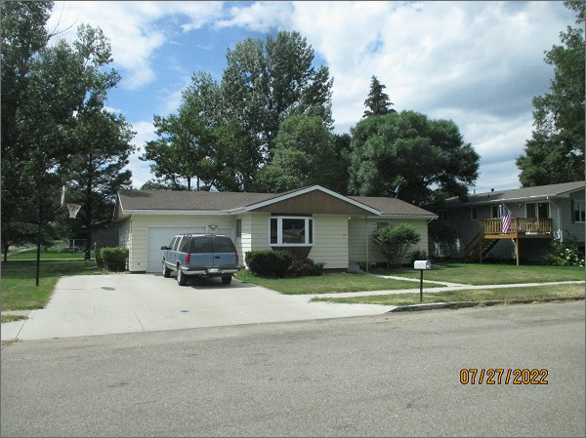
RECORD #6137
LOT SIZE: 95’ X 120’
YEAR BUILT: 1968
TYPE: SINGLE FAMILY
QUALITY: FAIR
CONDITION: AVERAGE
GROUND FLOOR AREA: 1040 SQFT
BASEMENT: 1040 SQFT
BEDROOMS: 2. BATHS: 1
FIXTURES: 5
GARAGE: ATTACHED: 384 SQFT
SOLD ON 12/30/21 FOR $135,000
SOLD ON 4/4/17 FOR $125,000
ASSESSED IN 2022 AT $122,020
ASSESSED IN 2017 AT $117,850

