$110,000
BERG & HICKS – MADISON
907 8TH AVENUE WEST
MOBRIDGE – NWTS CO’S 3RD ADDN., SOUTH 20’ LOT 3 & NORTH 30’ OF LOT 4, BLOCK 29
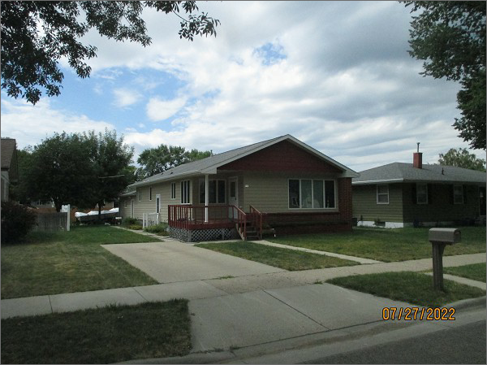
RECORD #6128
LOT SIZE: 50’ X 120’
YEAR BUILT: 1960
TYPE: SINGLE FAMILY
QUALITY: FAIR
CONDITION: AVERAGE
GROUND FLOOR AREA: 1287 SQFT
BASEMENT: 1287 SQFT
BEDROOMS: 3. BATHS: 1
FIXTURES: 8
GARAGE – ATTACHED: 678 SQFT
SOLD ON 12/17/21 FOR $110,000
ASSESSED IN 2022 AT $131,990
ASSESSED IN 2017 AT $129,790

