$110,000
DAKOTALAND FEDERAL CREDIT UNION – MEYER
808 8TH AVENUE WEST
MOBRIDGE – NWTS CO’S 2ND ADDN., NORTH 34’ OF LOT 9 & SOUTH 26’ OF LOT 10, BLOCK 24
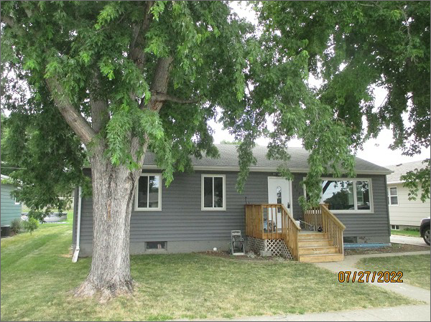
RECORD #6095
LOT SIZE: 60’ X 140’
YEAR BUILT: 1958
TYPE: SINGLE FAMILY
QUALITY: FAIR
CONDITION: BADLY WORN
GROUND FLOOR AREA: 1092 SQFT
BASEMENT: 1092 SQFT
BEDROOMS: 2. BATHS: 1
FIXTURES: 5
GARAGE – DETACHED: 336 SQFT. CARPORT: 220 SQFT
SOLD ON 1/26/22 FOR $110,000
SOLD ON 1/14/21 FOR $111,271
ASSESSED IN 2022 AT $76,910
ASSESSED IN 2017 AT $76,910

