$32,000
STEIGER GISI – WEISBECK
1102 7TH AVENUE WEST
MOBRIDGE – NWTS CO’S 2ND ADDN., LOT 9 & S 8’ OF LOT 10, BLK 20
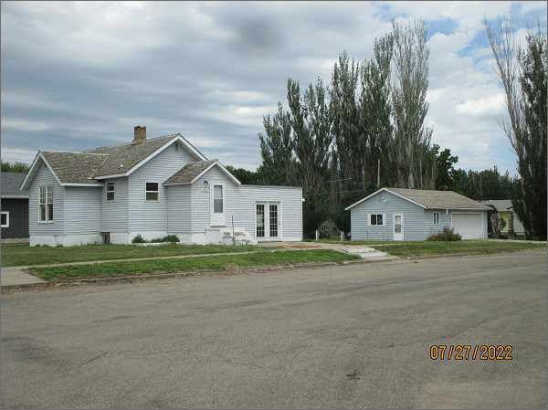
RECORD #6060
LOT SIZE: 54’ X 140’
YEAR BUILT: 1940
TYPE: SINGLE FAMILY
QUALITY: FAIR
CONDITION: BADLY WORN
GROUND FLOOR AREA: 1050 SQFT
BASEMENT: 1050 SQFT
BEDROOMS: 2. BATHS: 1
FIXTURES: 5
GARAGE – DETACHED: 682 SQFT
SOLD ON 6/9/22 FOR $32,000
SOLD ON 11/21/16 FOR $15,000
ASSESSED IN 2022 AT $60,210
ASSESSED IN 2016 AT $57,720

