$340,000.00
KRAFT – MARSHALL
1102 4TH AVENUE WEST
MOBRIDGE – NWTS CO’S 2ND ADDN., BLK 17, LTS 9 & 10 & S27’ OF 11
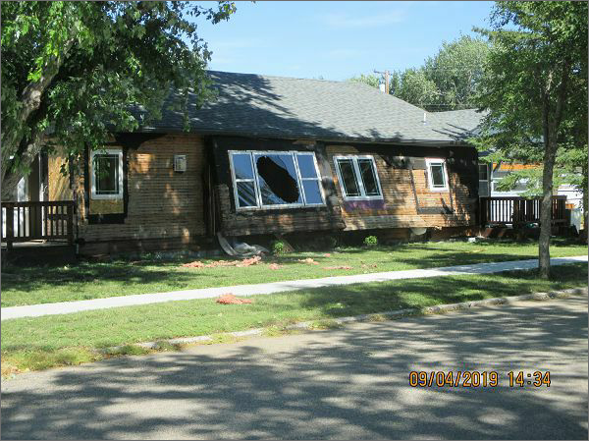
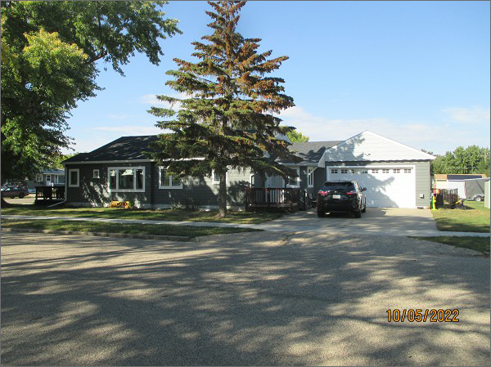
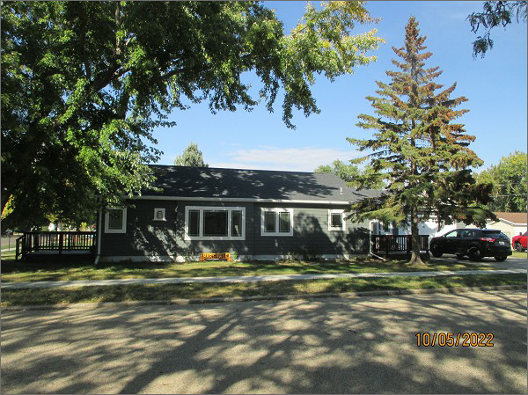
RECORD #6028
LOT SIZE: 119’ X 140’
YEAR BUILT: 1949
TYPE: SINGLE FAMILY
QUALITY: VERY GOOD
CONDITION: NEW
GROUND FLOOR AREA: 1608 SQFT
BASEMENT: 1608 SQFT
BEDROOMS: 4. BATHS: 3
FIXTURES: 11
GARAGE – ATTACHED: 660 SQFT
SOLD ON 7/13/2022 FOR $340,000
CONDITION OF HOUSE IN 2019 BEFORE TOTAL REMODEL.
SOLD ON 4/16/2019 FOR $120,000
ASSESSED IN 2022 AT $25,120
ASSESSED IN 2017 AT $130,120

