$67,000.00
PESKEY/DUCHENEAUX – ABERLE
805 3RD AVENUE WEST
MOBRIDGE – NWTS COMPANY’S 1ST ADDN., BLOCK 12, LOT 6
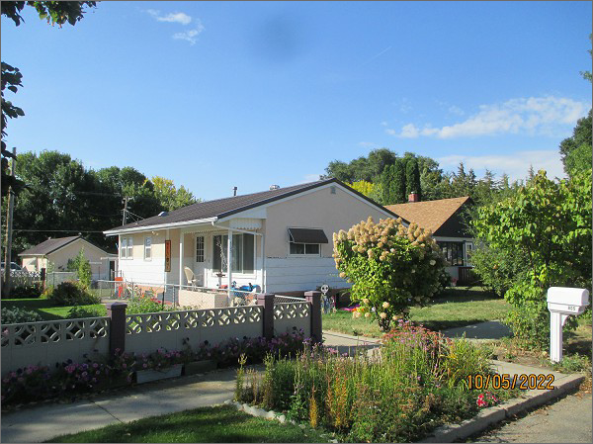
RECORD #5979
LOT SIZE: 40’ X 140’
YEAR BUILT: 1960
TYPE: SINGLE FAMILY
QUALITY: FAIR
CONDITION: AVERAGE
GROUND FLOOR AREA: 893 SQFT
BASEMENT: 893 SQFT
BEDROOMS: 3. BATHS: 2.5
FIXTURES: 8
GARAGE – DETACHED: 472 SQFT
SOLD ON 8/25/2022 FOR $67,000
SOLD ON 1/5/2018 FOR $65,000
ASSESSED IN 2022 AT $72,980
ASSESSED IN 2017 AT $71,130

