$242,000
RETTERATH – DALE
911 3RD AVENUE WEST
MOBRIDGE – NWTS CO’S 1ST ADDN., LOTS 5 & 6, BLOCK 9
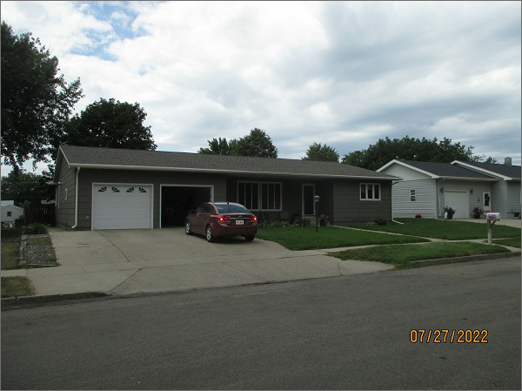
RECORD #5952
LOT SIZE: 80’ X 140’
YEAR BUILT: 1960
TYPE: SINGLE FAMILY
QUALITY: AVERAGE
CONDITION: AVERAGE
GROUND FLOOR AREA: 2139 SQFT
BASEMENT: 1664 SQFT
BEDROOMS: 3. BATHS: 2
FIXTURES: 11
GARAGE – ATTACHED: 525 SQFT
SOLD ON 5/6/22 FOR $242,000
SOLD ON 12/14/12 FOR $200,000
ASSESSED IN 2022 AT $207,820
ASSESSED IN 2017 AT $204,130
ASSESSED IN 2012 AT $111,535

