$140,000
KOENIG – UMALI
913 4TH AVENUE WEST
MOBRIDGE – NWTS CO’S 1ST ADDN., LOT 3, BLOCK 8
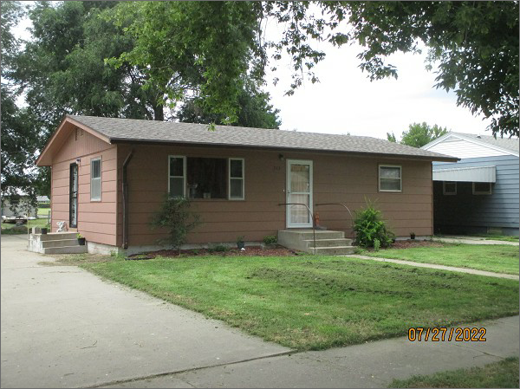
RECORD #5943
LOT SIZE: 60’ X 140’
YEAR BUILT: 1955
TYPE: SINGLE FAMILY
QUALITY: FAIR
CONDITION: AVERAGE
GROUND FLOOR AREA: 1310 SQFT
BASEMENT: 1310 SQFT
BEDROOMS: 3. BATHS: 1
FIXTURES: 5
GARAGE – ATTACHED: 408 SQFT
SOLD ON 5/25/22 FOR $140,000
ASSESSED IN 2022 AT $89,510
ASSESSED IN 2017 AT $86,740

