$172,500
HUNNEL – SALZER
1005 4TH AVENUE WEST
MOBRIDGE – NWTS CO’S 1ST ADDN., SOUTH 42.5’ OF LOT 4 & NORTH 17.5’ OF LOT 5, BLOCK 3
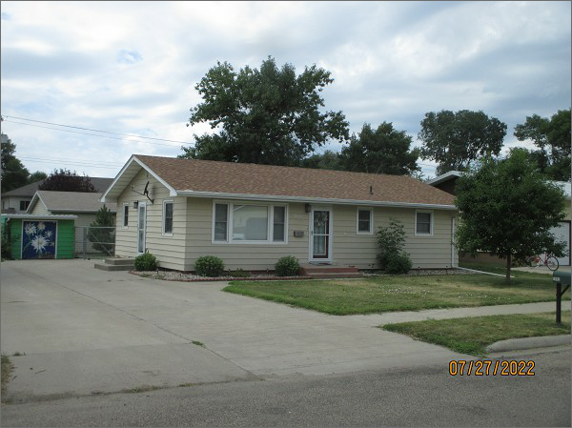
RECORD #5922
LOT SIZE: 60’ X 140’
YEAR BUILT: 1965
TYPE: SINGLE FAMILY
QUALITY: FAIR
GROUND FLOOR AREA: 1025 SQFT
BASEMENT: 1025 SQFT
BEDROOMS: 3. BATHS: 2
FIXTURES: 8
GARAGE – DETACHED: 864 SQFT
SOLD ON 5/23/22 FOR $172,500
SOLD ON 3/12/20 FOR $150,000
ASSESSED IN 2022 AT $122,890
ASSESSED IN 2017 AT $120,120

