$99,000.00
FORBES – TISSAW
414 2ND AVENUE WEST
MOBRIDGE – MILW LAND CO’S 1ST ADDN, BLOCK 23, LOT 10
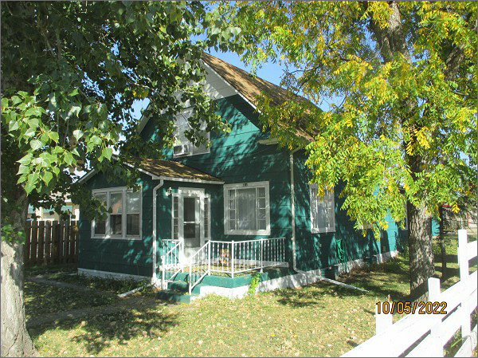
RECORD #5821
LOT SIZE: 50’ X 140’
YEAR BUILT: 1930
TYPE: SINGLE FAMILY
QUALITY: FAIR
CONDITION: BADLY WORN
GROUND FLOOR AREA: 1175 SQFT
BASEMENT: 1175 SQFT
BEDROOMS: 4. BATHS: 1 FULL, 1 – 3/4, 1 – 1/2
FIXTURES: 5
GARAGE – DETACHED: 364 SQFT
SOLD ON 7/18/2022 FOR $99,000
SOLD ON 8/1/2019 FOR $29,000
ASSESSED IN 2022 AT $28,920
ASSESSED IN 2017 AT $33,470

