$60,000
FREDRICKSEN – MERKEL
1007 NORTH MAIN ST
MOBRIDGE – MAIN PARK, LOT 5 & N 2 ½’ OF LOT 6, BLOCK 18
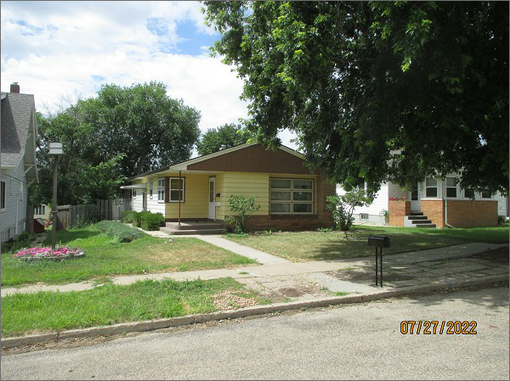
RECORD #5662
LOT SIZE: 40’ X 152’
YEAR BUILT: 1955
TYPE: SINGLE FAMILY
QUALITY: LOW/FAIR
CONDITION: AVERAGE
GROUND FLOOR AREA: 1088 SQFT
BASEMENT: 1088 SQFT
BEDROOMS: 2. BATHS: 1.5
FIXTURES: 8
GARAGE – DETACHED: 315 SQFT
SOLD ON 5/17/22 FOR $60,000
ASSESSED IN 2022 AT $91,380
ASSESSED IN 2017 AT $39,200

