$72,000
BORAH & THOMPSON – MERKEL
906 NORTH MAIN ST
MOBRIDGE – MAIN PARK, LOT 11 & S. ½ OF LOT 12, BLOCK 14
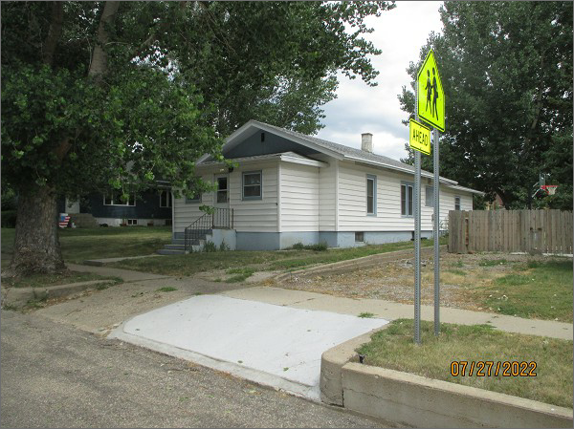
RECORD #5643
LOT SIZE: 56.25’ X 125’
YEAR BUILT: 1925
TYPE: SINGLE FAMILY
QUALITY: FAIR
CONDITION: AVERAGE
GROUND FLOOR AREA: 1425 SQFT
BASEMENT: 900 SQFT
BEDROOMS: 4. BATHS: 1.5
FIXTURES: 7
GARAGE – DETACHED: 396 SQFT
SOLD ON 11/1/21 FOR $72,000
ASSESSED IN 2022 AT $65,160
ASSESSED IN 2020 AT $62,640
ASSESSED IN 2017 AT $38,155

