$132,000.00
GELDERMAN/MERTZ – SANDERS
809 2ND AVENUE EAST
MOBRIDGE – MAIN PARK, BLOCK 12, LOTS 3 & 4
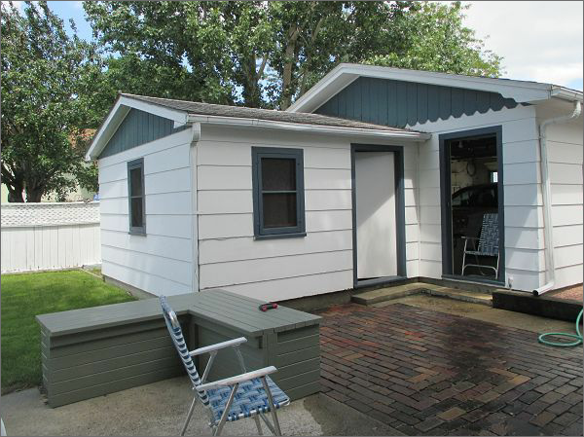
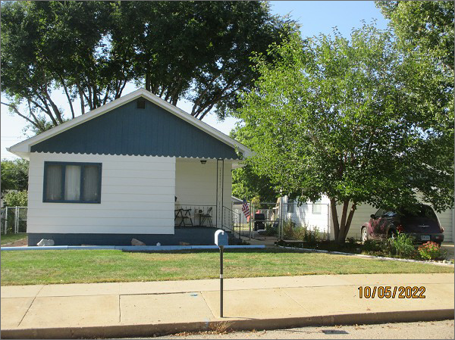
RECORD #5615
LOT SIZE: 75’ X 142’
YEAR BUILT: 1915
TYPE: SINGLE FAMILY
QUALITY: FAIR
CONDITION: AVERAGE
GROUND FLOOR AREA: 992 SQFT
BASEMENT: 992 SQFT
BEDROOMS: 2. BATHS: 1.75
FIXTURES: 8
GARAGE – DETACHED: 520 SQFT
SOLD ON 3/31/2022 FOR $132,000
ASSESSED IN 2022 AT $75,250
ASSESSED IN 2017 AT $72,220
ASSESSED IN 2012 AT $30,575

