$135,000.00
BUNN - NICHOLSON
1209 SUNSET DRIVE
MOBRIDGE – JAY-KRAFT 1ST ADDN, BLOCK 3, LOT 5
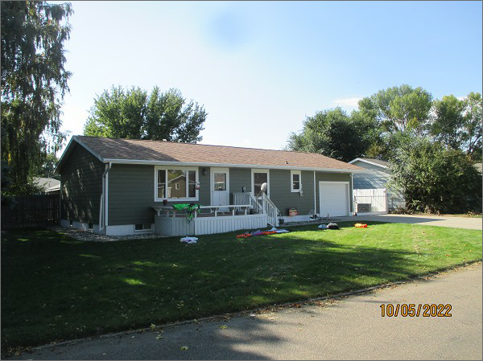
RECORD #5535
LOT SIZE: 84’ X 95’
YEAR BUILT: 1979
TYPE: SINGLE FAMILY
QUALITY: FAIR
CONDITION: AVERAGE
GROUND FLOOR AREA: 1040 SQFT
BASEMENT: 1040 SQFT
BEDROOMS: 2. BATHS: 2.5
FIXTURES: 8
GARAGE – ATTACHED: 336 SQFT
SOLD ON 7/29/2022 FOR $135,000
SOLD ON 1/15/2016 FOR $120,000
ASSESSED IN 2022 AT $107,490
ASSESSED IN 2016 AT $104,150

