$105,000.00
TRUEBLOOD FOR BAKKEGARD – MATT KELLER PROPERTIES LLC
1205 SUNSET DRIVE
MOBRIDGE – JAY-KRAFT 1ST ADDN, BLK 3, E 15’ OF LOT 3 & ALL LOT 4
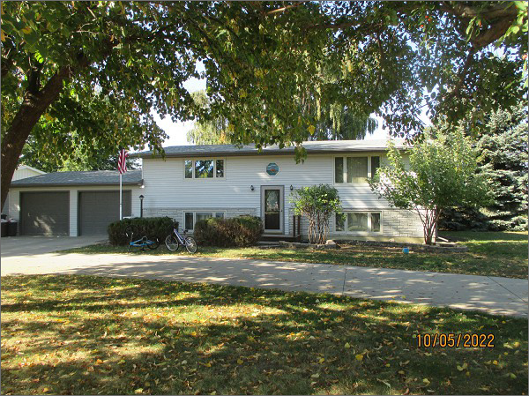
RECORD #5534
LOT SIZE: 99’ X 97’
YEAR BUILT: 1978
TYPE: SINGLE FAMILY
QUALITY: FAIR
CONDITION: AVERAGE
GROUND FLOOR AREA: 1008 SQFT
BASEMENT: 1008 SQFT
BEDROOMS: 3. BATHS: 2.5
FIXTURES: 8
GARAGE – ATTACHED: 576 SQFT
SOLD ON 8/6/2022 FOR $105,000
ASSESSED IN 2022 AT $129,750
ASSESSED IN 2017 AT $125,770

