$54,500.00
RAUSH – FRAILING
621 3RD AVENUE EAST
MOBRIDGE – GRAND CROSSING ADDN., BLK 61, LOT 13A
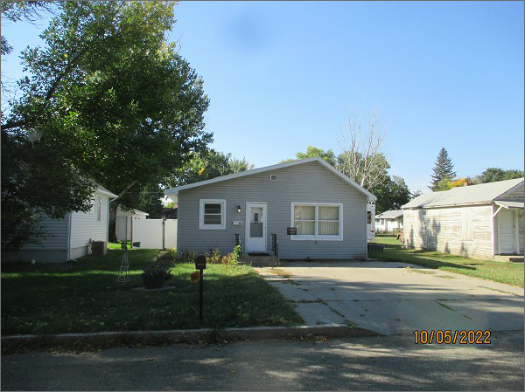
RECORD #5497
LOT SIZE: 43’ X 140’
YEAR BUILT: 1920
TYPE: SINGLE FAMILY
QUALITY: FAIR
CONDITION: BADLY WORN
GROUND FLOOR AREA: 675 SQFT
BEDROOMS: 2. BATHS: 1.5
FIXTURES: 5
SOLD ON 8/22/2022 FOR $54,500
SOLD ON 8/11/2016 FOR $34,000
ASSESSED IN 2022 AT $32,040
ASSESSED IN 2017 AT $31,050
ASSESSED IN 2012 AT $16,680

