$45,000.00
U.S. BANK NATIONAL ASSOCIATION – KONOLD
705 4TH AVENUE EAST
MOBRIDGE – GRAND CROSSING ADDN., BLK 61, LOTS 2B & 2C
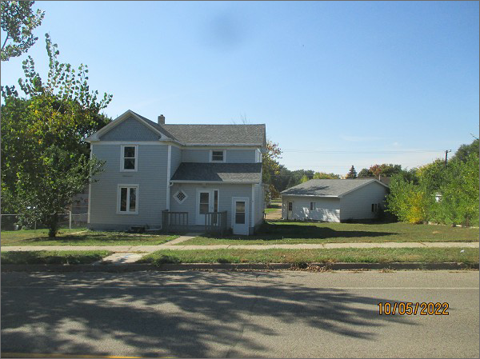
RECORD #5474
LOT SIZE: 86’ X 140’
YEAR BUILT: 1920
TYPE: SINGLE FAMILY
QUALITY: FAIR
CONDITION: AVERAGE
GROUND FLOOR AREA: 930 SQFT
BASEMENT: 724 SQFT
BEDROOMS: 4. BATHS: 3
FIXTURES: 10
GARAGE – DETACHED: 240 SQFT
SOLD ON 7/14/2022 FOR $45,000
SOLD ON 8/13/2012 FOR $75,000
ASSESSED IN 2022 AT $82,890
ASSESSED IN 2012 AT $53,710

