$116,000
DURBIN – CLOUD
713 2ND AVENUE EAST
MOBRIDGE – GRAND CROSSING ADDN., BLOCK 60, LOT 4
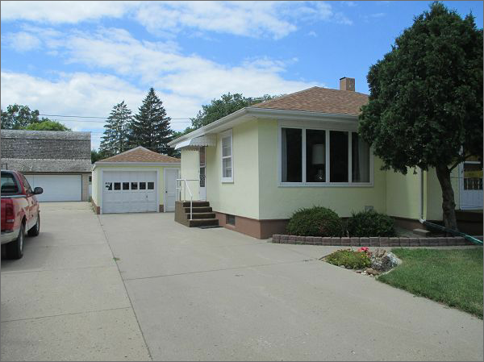
RECORD #5463
LOT SIZE: 50’ X 140’
YEAR BUILT: 1950
TYPE: SINGLE FAMILY
QUALITY: FAIR
CONDITION: AVERAGE
GROUND FLOOR AREA: 803 SQFT
BASEMENT: 793 SQFT
BEDROOMS: 2. BATHS: 1- ¾ 1- 1/2: 1.25 TOTAL
FIXTURES: 5
GARAGE – DETACHED: 828 SQFT
SOLD ON 1/14/22 FOR $116,000
SOLD ON 8/12/16 FOR $80,000
ASSESSED IN 2022 AT $78,540
ASSESSED IN 2016 AT $62,370

