$120,000.00
SMOLIK – MICKELSON
706 2ND AVENUE WEST
MOBRIDGE – GRAND CROSSING ADDN, BLOCK 57, LOT 8
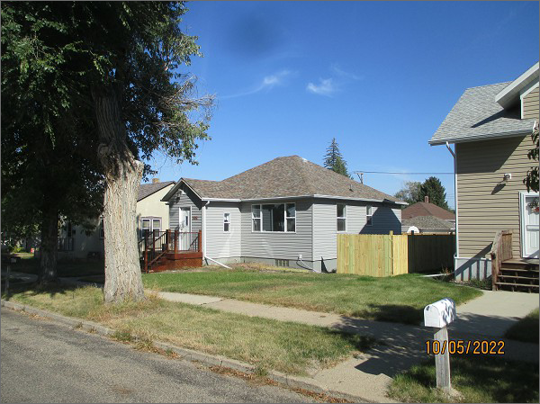
RECORD #5437
LOT SIZE: 50’ X 140’
YEAR BUILT: 1910
TYPE: SINGLE FAMILY
QUALITY: FAIR
CONDITION: AVERAGE
GROUND FLOOR AREA: 896 SQFT
BASEMENT: 896 SQFT
BEDROOMS: 3. BATHS: 2 - FULL, 2- ¾
FIXTURES: 5
GARAGE – DETACHED: 352 SQFT
SOLD ON 4/22/2022 FOR $120,000
SOLD ON 6/25/2012 FOR $42,500
ASSESSED IN 2022 AT $46,880
ASSESSED IN 2012 AT $27,310

